**Computer Hardware**

Computer hardware refers to the physical components that make up a computer system. These components work together to process data and execute instructions. Understanding the major hardware components is essential for building, maintaining, and troubleshooting computers.

**Motherboard**

* The **motherboard** is the main circuit board of a computer.
* It houses the CPU, RAM, storage connectors, and other critical components.
* Provides connectivity for peripherals through slots and ports.
* Key features:
  + CPU socket
  + RAM slots
  + Expansion slots (e.g., PCIe)
  + Connectors for storage devices (e.g., SATA, M.2)
  + BIOS/UEFI chip

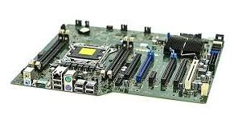

**RAM (Random Access Memory) Modules**

* **RAM** is temporary memory used to store data and instructions for quick access by the CPU.
* Types of RAM:
  + DDR4, DDR5 (common in modern systems)
  + SODIMM (used in laptops)
* RAM modules are installed in slots on the motherboard.

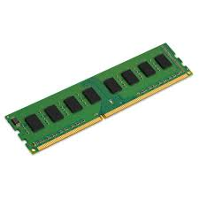

**Daughter Cards**

* **Daughter cards** are secondary circuit boards that connect to the motherboard to provide additional functionality.
* Examples:
  + Graphics cards (GPU)
  + Sound cards
  + Network interface cards (NIC)

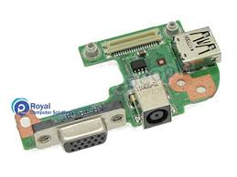

**SMPS (Switched-Mode Power Supply)**

* The **SMPS** converts AC power from the wall outlet into DC power for the computer's internal components.
* Provides power to the motherboard, CPU, storage devices, and peripherals.
* Rated by wattage (e.g., 500W, 750W).

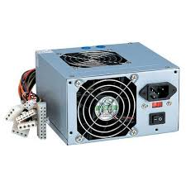

**Interfacing Ports**

* Ports allow external devices to connect to the computer.
* Common ports:
  + USB (Universal Serial Bus)
  + HDMI/DisplayPort (for monitors)
  + Ethernet (for networking)

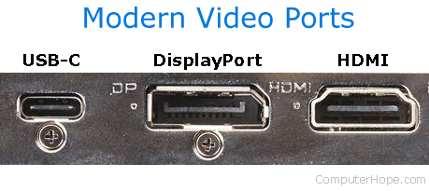

**Internal Storage Devices**

* **HDD (Hard Disk Drive)**: Traditional magnetic storage with high capacity but slower speeds.
* **SSD (Solid State Drive)**: Faster, more reliable storage with no moving parts.

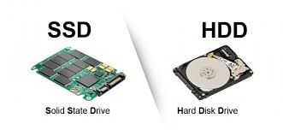

**Bus Slots**

* **Bus slots** are connectors on the motherboard that allow expansion cards to be added.
* Common types:
  + PCI (Peripheral Component Interconnect)
  + PCIe (PCI Express) – widely used for GPUs and high-speed devices.

